Glasgow Police Department
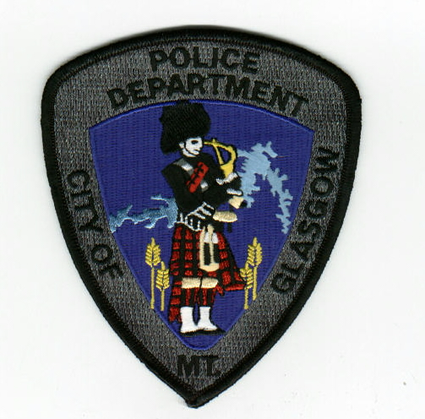
Open Container/Street Closure
Permit Application

Open Container Permit Guidelines

- A copy of the permit application will be distributed to all neighbors/neighboring businesses in the permitted area of the party at least five (5) days prior to the event. If any affected party does not agree, the permit will be reviewed. Any affected party that does not agree must make it known by calling the police department and speaking with the Secretary or Chief of Police.

- A temporary barricade shall be set up in a manner that any emergency vehicles may still move freely through the permitted area.

- The permitted area will be roped off or defined by commercial banners outlining the borders. Signs will be posted at the borders of the area stating that no alcohol will be allowed past that point. All alcoholic beverages served for the permitted area should be in cans or plastic containers.

- All garbage will be cleaned within 12 hours after the event and prior to the deposit of $150 being returned. If the permitted area is not cleaned up to the satisfaction of the Public Works Director or the Chief of Police, the deposit will be retained and turned over to the City of Glasgow.

- Noise must be kept down so as not to disturb adjoining neighborhoods or persons in residential areas. If the Police Department receives a complaint, the Investigating Officer will speak with the owner of the business or the sponsor of the event. If a resolution cannot be reached the permit will be voided and the owner may face criminal charges for Disturbing the Peace.

- In the event that Law Enforcement is called, and the investigating officers substantiate the event is becoming riotous or disruptive to the peace and safety of the community, the event will be shut down and the permit will be void.

I have read and understand the guidelines set forth by the Glasgow Police Department. Furthermore, I understand that the open container permit will be voided in the event that these guidelines are not followed. I understand that if the open container permit is voided I will not be allowed to have any open containers on the sidewalks or other public property of Glasgow and that I will be cited for such a violation.

Applicant/Business Name

Applicant/Business Address

Applicant Phone #

Location of Permit

Will Alcoholic Beverages be present in the permitted area? _____________________________

Is an alley or city street closure required? ____________________________________________

Note: If a state roadway within the City of Glasgow closure is required, applicant must have prior state approval.

Date Permit Requested Time of Event Start A.M. / P.M. End A.M. / P.M.

Will there be music? Do all neighbors/neighboring businesses agree?

What time will the music begin? End?

Applicant Signature __

Chief Signature ___

Approved? Deposit Collected ($150)? Disposition of Deposit

(Retained, Refunded, or Destroyed)

Copy of permit provided to Public Works Director? ____ Yes ____ No

